HTML 5
Project Theme: Local Community Event Portal
1. Create the HTML5 Base Template
CODE :
<!DOCTYPE html>
<html lang="en">
<head>
<meta charset="UTF-8">
<meta name="viewport" content="width=device-width, initial-scale=1.0">
<title>Local Community Event Portal</title>
</head>
<body>
<!-- Navigation -->
<nav>
<h2>Community Portal</h2>
<ul>
<li><a href="#">Home</a></li>
<li><a href="#">Events</a></li>
<li><a href="#">Contact</a></li>
</ul>
</nav>
<!-- Main -->
<main>
<h1>Welcome to the Local Community Event Portal</h1>
<p>This portal helps residents register for events and access services.</p>
</main>
<!-- Footer -->
<footer>
<p>&copy; 2026 Local Community Portal</p>
</footer>
</body>
</html>
OUTPUT :
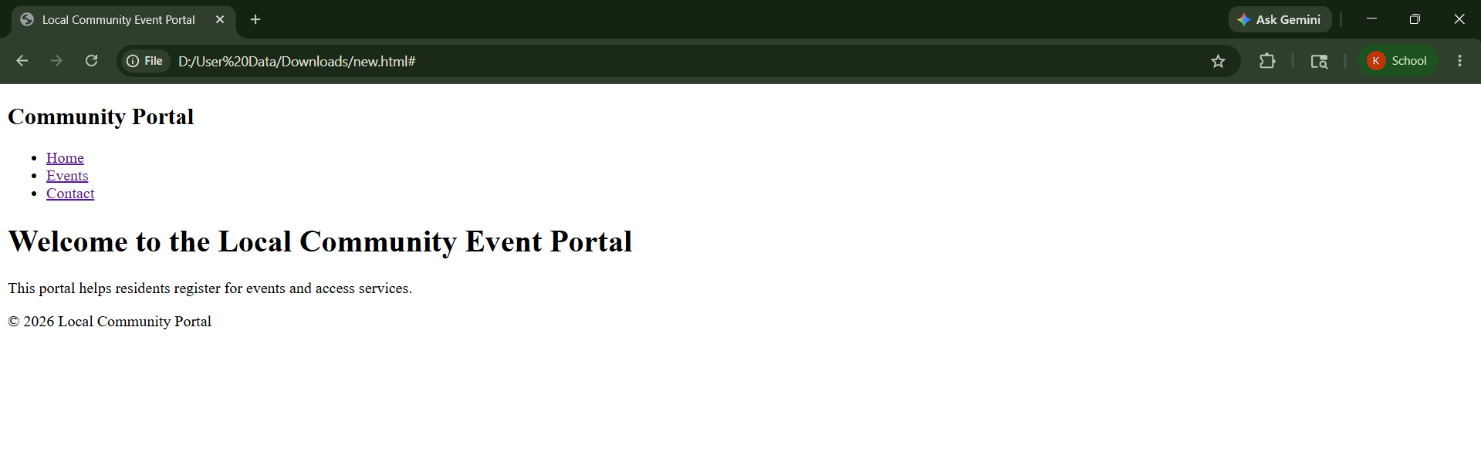
2. Navigation and Linking
CODE :
<!DOCTYPE html>
<html lang="en">
<head>
<meta charset="UTF-8">
<title>Navigation Example</title>
</head>
<body>
<!-- Navigation -->
<nav>
<a href="#home">Home</a> |
<a href="#events">Events</a> |
<a href="#contact">Contact</a> |
<a href="help.html" target="_blank">Help</a>
</nav>
<!-- Home Section -->
<section id="home">
<h1>Home Section</h1>
<p>Welcome to the portal.</p>
</section>
<!-- Events Section -->
<section id="events">
<h1>Events Section</h1>
<p>Community events are listed here.</p>

OUTPUT :
</section>
<!-- Contact Section -->
<section id="contact">
<h1>Contact Section</h1>
<p>Contact us for more details.</p>
</section>
</body>
</html>

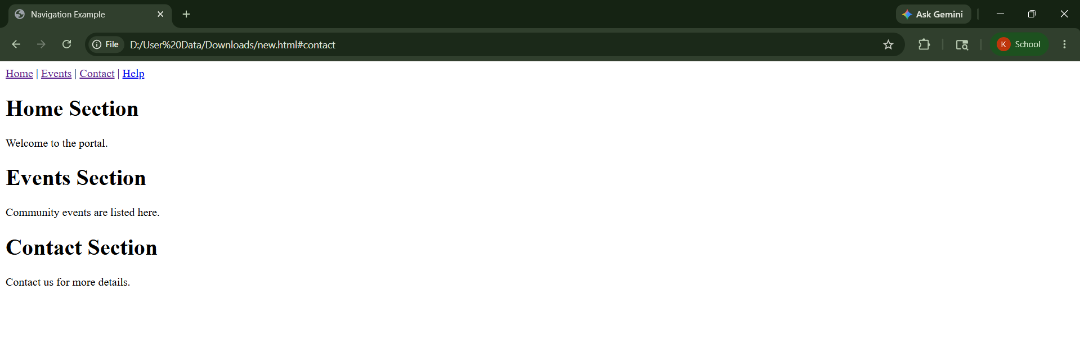
3. Welcome Message with Styling and ID/Class
CODE :
<!DOCTYPE html>
<html lang="en">
<head>
<meta charset="UTF-8">
<title>Welcome Banner</title>
<style>
#welcomeBanner {
background-color: blue;
color: white;
padding: 15px;
}
.highlight {
background-color: yellow;
font-weight: bold;
}
</style>

OUTPUT:
</head>
<body>
<!-- Welcome Banner -->
<div id="welcomeBanner">
<h1>Welcome User!</h1>
<p class="highlight">Glad to see you again.</p>
<p>
Special Offer:
<span style="color:red; font-weight:bold;">
50% Discount Today!
</span>
</p>
</div>
</body>
</html>

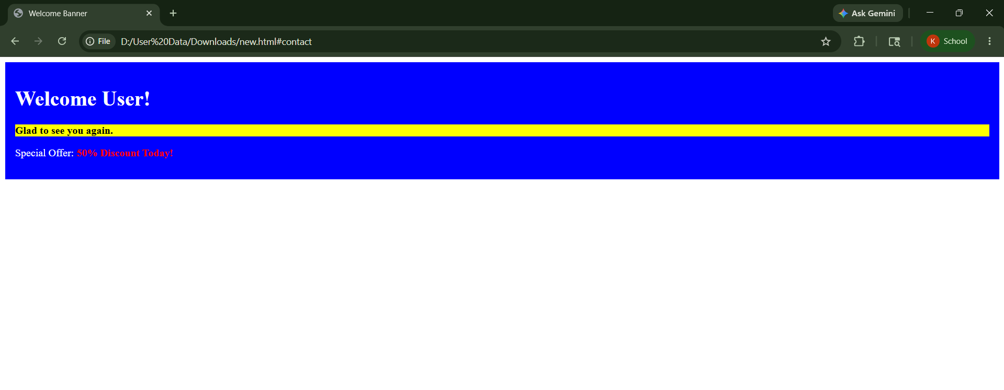

4. Image Gallery for Community EventsCODE :
<!DOCTYPE html>
<html lang="en">
<head>
<meta charset="UTF-8">
<title>Event Gallery</title>
<style>
.event-img {
border: 3px solid black;
width: 200px;
height: 120px;
}
</style>
</head>
<body>
<h1>Community Event Gallery</h1>
<table border="1">
<tr>
<td>
<img src="event1.jpg" alt="Music Event"
title="Music Event" class="event-img">
<p><b>Music Festival</b></p>
</td>
<td>
<img src="event2.jpg" alt="Food Event"
title="Food Event" class="event-img">
<p><b>Food Carnival</b></p>
</td>
<td>
<img src="event3.jpg" alt="Sports Event"
title="Sports Event" class="event-img">
<p><b>Sports Meet</b></p>
</td>
</tr>
<tr>
<td>
<img src="event4.jpg" alt="Art Event"
title="Art Event" class="event-img">
<p><b>Art Exhibition</b></p>
</td>
<td>
<img src="event5.jpg" alt="Dance Event"
title="Dance Event" class="event-img">
<p><b>Dance Program</b></p>
</td>
<td>
<img src="event6.jpg" alt="Community Meeting"
title="Community Meeting" class="event-img">
<p><b>Community Meetup</b></p>
</td>
</tr>
</table>
</body>
</html>
OUTPUT :

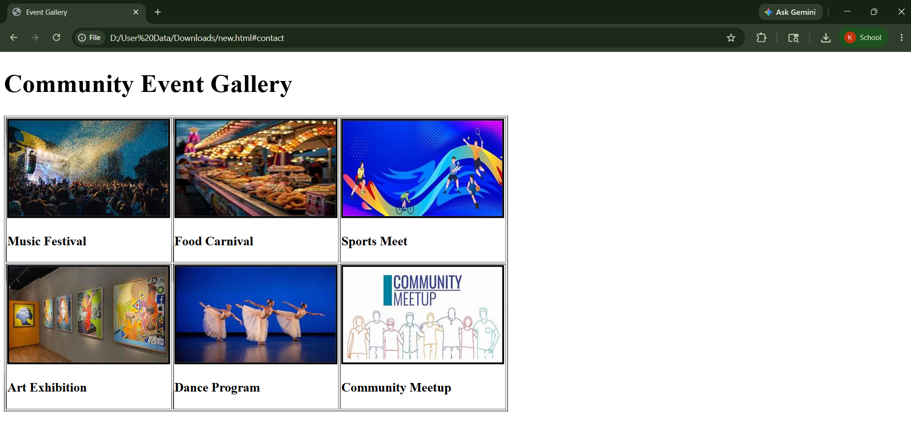
5. Event Registration Form
CODE :
<!DOCTYPE html>
<html lang="en">
<head>
<meta charset="UTF-8">
<title>Event Registration Form</title>
<style>
form {
width: 300px;
padding: 20px;
border: 2px solid black;
background-color: lightgray;
}
input, select, textarea {
width: 100%;
margin-bottom: 10px;
padding: 5px;
}
button {
background-color: blue;
color: white;
padding: 8px;
}
</style>
</head>
<body>
<h2>Event Registration</h2>
<form onsubmit="showMessage(); return false;">
<input type="text" placeholder="Enter your name"
required autofocus>
<input type="email" placeholder="Enter your email"
required>

OUTPUT :
<input type="date" required>
<select required>
<option value="">Select Event</option>
<option>Music Event</option>
<option>Sports Event</option>
<option>Food Festival</option>
</select>
<textarea placeholder="Enter your message"
required></textarea>
<button type="submit">Register</button>
<br><br>
<output id="result"></output>
</form>
<script>
function showMessage() {
document.getElementById("result").innerHTML =
"Registration Successful!";
}
</script>
</body>
</html>

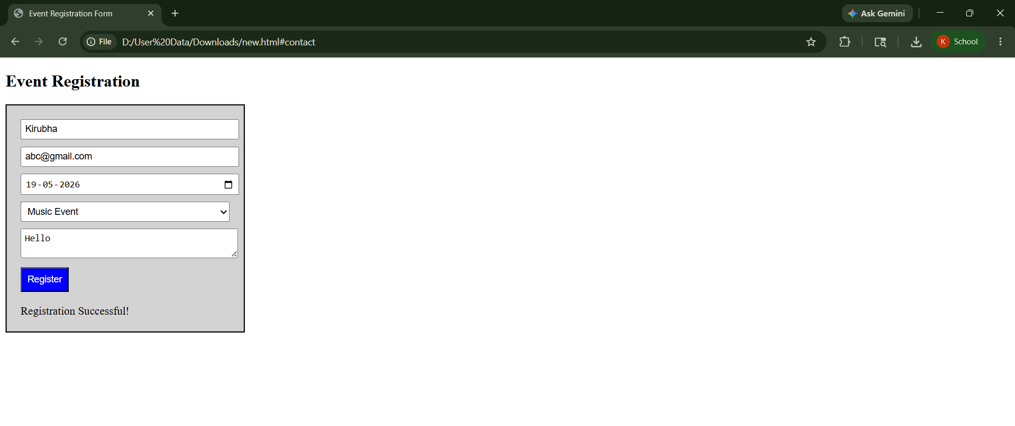
6. Event Feedback with Events Handling
CODE:
<!DOCTYPE html>
<html lang="en">
<head>
<meta charset="UTF-8">
<title>Event Feedback</title>
</head>
<body>
<input type="text" id="phone"
placeholder="Phone Number"
onblur="checkPhone()">
<p id="msg"></p>
<select onchange="showFee(this.value)">
<option value="">Select Event</option>
<option value="100">Music</option>
<option value="200">Sports</option>
</select>
<p id="fee"></p>
<textarea id="feed"
onkeyup="countChar()"
placeholder="Feedback"></textarea>
<p>Count: <span id="count">0</span></p>
<button onclick="submitForm()">Submit</button>
<br><br>
<img src="event.jpg" width="100"
ondblclick="big(this)">
<script>
function checkPhone() {
let p = document.getElementById("phone").value;
document.getElementById("msg").innerHTML =
(p.length == 10) ? "Valid" : "Invalid";
}
function showFee(v) {
document.getElementById("fee").innerHTML =
"Fee: ₹" + v;
}
function submitForm() {
alert("Submitted");
}
function big(img) {
img.width = 200;
}
function countChar() {
let t = document.getElementById("feed").value;
document.getElementById("count").innerHTML =
t.length;
}
</script>
</body>
</html>

OUTPUT :

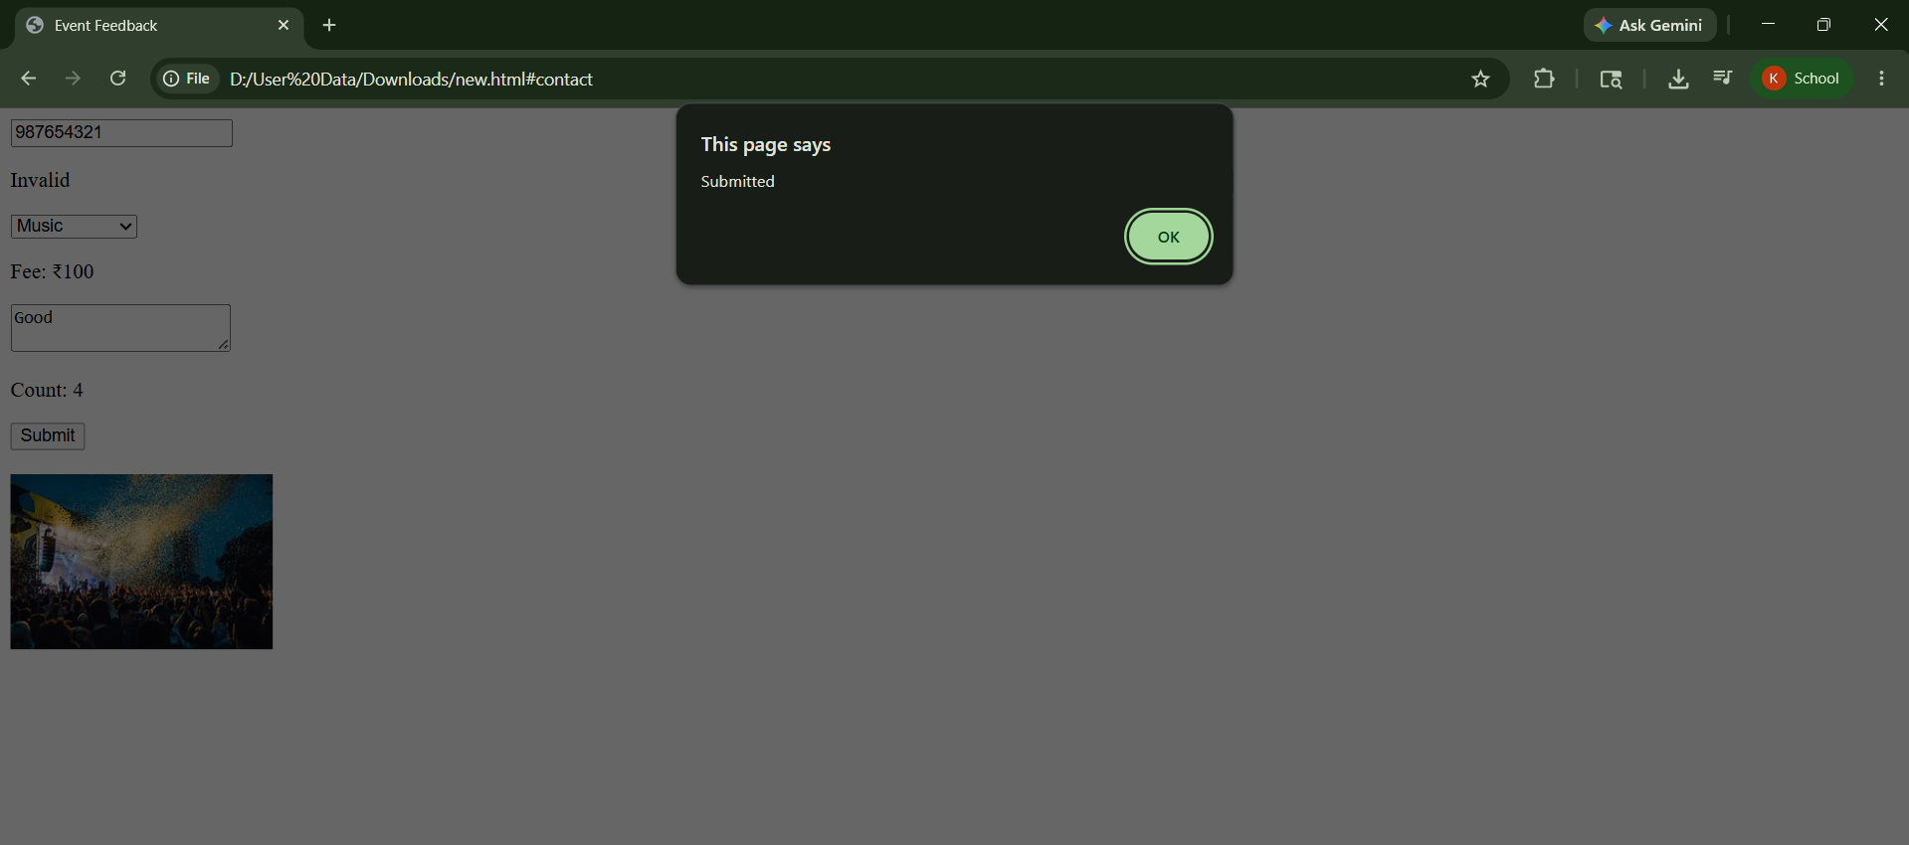

7. Video Invite with Media Events
CODE :
<!DOCTYPE html>
<html lang="en">
<head>
<meta charset="UTF-8">
<title>Video Invite</title>
</head>
<body>
<h2>Event Promo Video</h2>
<video width="300" controls oncanplay="readyMsg()">
<source src="video.mp4" type="video/mp4">
</video>
<p id="msg"></p>
<script>
function readyMsg() {
document.getElementById("msg").innerHTML =
"Video ready to play";
}
window.onbeforeunload = function() {
return "Form not completed!";
};
</script>
</body>
</html>
OUTPUT :
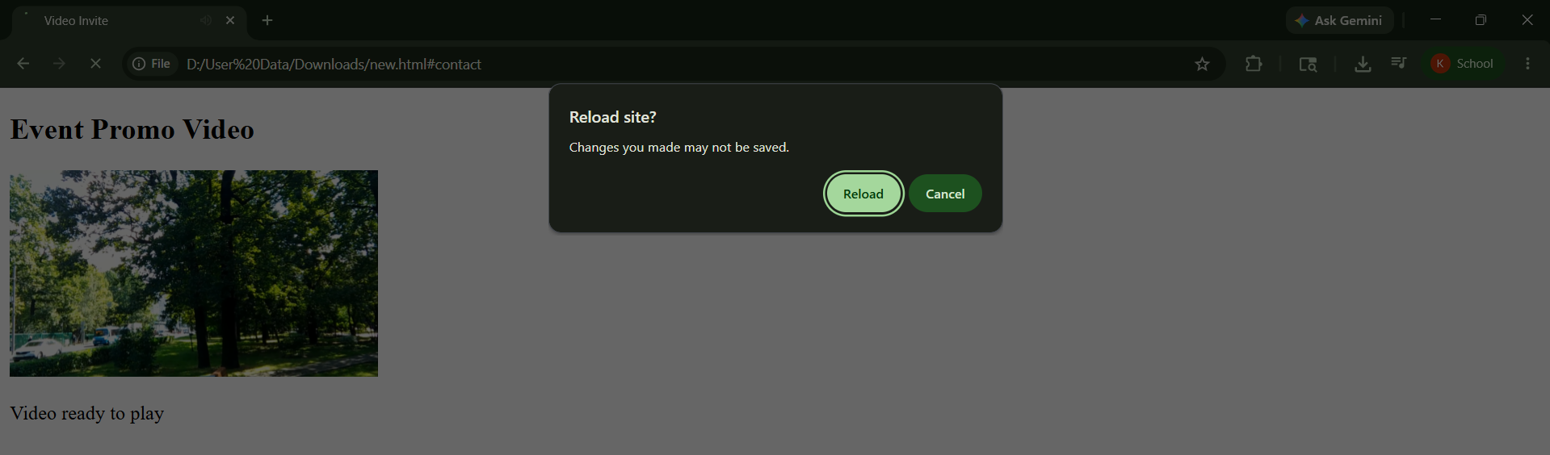
8. Saving User Preferences
CODE :
<!DOCTYPE html>
<html lang="en">
<head>
<meta charset="UTF-8">
<title>User Preferences</title>
</head>
<body>
<h2>Select Event</h2>
<select id="event">
<option>Music</option>
<option>Sports</option>
<option>Food Festival</option>
</select>
<button onclick="saveData()">Save</button>
<button onclick="clearData()">Clear Preferences</button>
<script>
let eventBox = document.getElementById("event");
window.onload = function () {
let saved = localStorage.getItem("event");
if(saved) {
eventBox.value = saved; } }
function saveData() {
localStorage.setItem("event", eventBox.value);
sessionStorage.setItem("event", eventBox.value);
alert("Preference Saved"); }
function clearData() {
localStorage.clear();
sessionStorage.clear();
alert("Preferences Cleared"); }
</script>
</body>
</html>
OUTPUT :
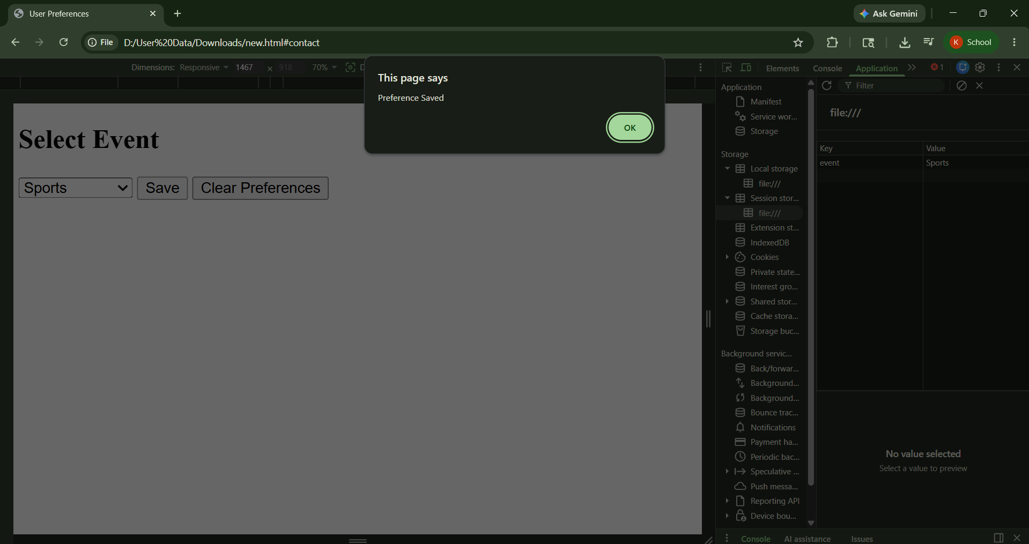
9. Geolocation for Event Mapping
CODE :
<!DOCTYPE html>
<html lang="en">
<head>
<meta charset="UTF-8">
<title>Geolocation</title>
</head>
<body>
<button onclick="findLocation()">
Find Nearby Events
</button>
<p id="result"></p>
<script>
function findLocation() {
if (navigator.geolocation) {
navigator.geolocation.getCurrentPosition(
showPosition,
showError, {
enableHighAccuracy: true,
timeout: 20000 }

OUTPUT :

);
} else {
document.getElementById("result").innerHTML =
"Geolocation not supported";
}
}
function showPosition(position) {
document.getElementById("result").innerHTML =
"Latitude: " + position.coords.latitude +
"<br>Longitude: " + position.coords.longitude +
"<br>Nearby events found!";
}
function showError(error) {
if (error.code == 1)
alert("Allow location permission");
else if (error.code == 2)
alert("Location unavailable");
else if (error.code == 3)
alert("Request timeout");
}
</script>
</body>
</html>

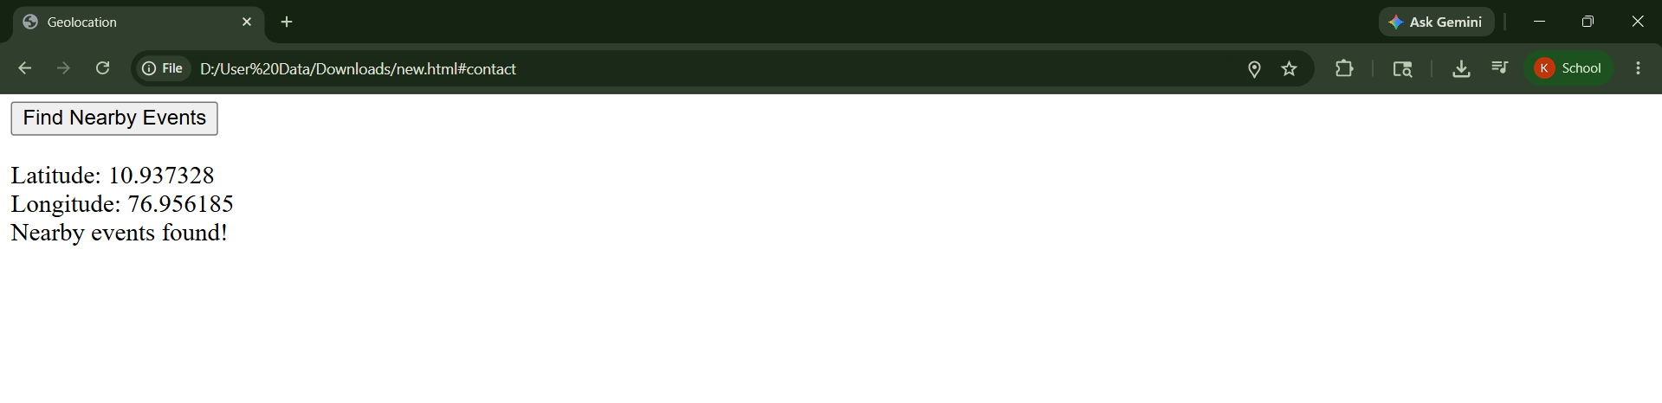
10. Debugging with Chrome DevTools

CODE :
<!DOCTYPE html>
<html lang="en">
<head>
<meta charset="UTF-8">
<title>Debug Example</title>
<style>
h1 {
color: blue;
}
</style>
</head>
<body>
<h1 id="title">Community Portal</h1>
<button onclick="showMsg()">Click</button>
<script>
function showMsg() {
let name = "User";
console.log("Button Clicked");
console.log(name);
alert("Welcome " + name);
}
</script>
</body>
</html>

OUTPUT :

